- Raw Data Overview
The dataset used in this project contains 541,910 rows and 8 columns, recording online retail transactions from 2010 to 2011. The data comes from the UCI Machine Learning Repository (Online Retail II dataset), which provides real transaction records from a UK-based online retailer. The fields include:

Invoice | Invoice number (those starting with “C” indicate returns)
StockCode | Product code
Description | Product description
Quantity | Quantity purchased
InvoiceDate | Transaction date and time
Price | Unit price
CustomerID | Customer identifier
Country | Customer’s country

Invoice | Stockcode | Description | Quantity | InvoiceDate | Price | Customer ID | Country
536365 | 85123A | WHITE HANGING HEART  T-LIGHT HOLDER | 6 | 2010-12-01 08:26:00 | 2.55 | 17850 | United Kingdom
536365 | 71053 | WHITE METAL LANTERN | 6 | 2010-12-01 08:26:00 | 3.39 | 17850 | United Kingdom
536365 | 84406B | CREAM CUPID HEARTS COAT HANGER | 8 | 2010-12-01 08:26:00 | 2.75 | 17850 | United Kingdom
Figure 1.1: The first 3 rows of raw data

- Data Cleaning
A quick check of the dataset shows that the data is generally clean. The only issue is returned items, which appear as transactions with negative quantities. After removing these return records, the remaining dataset contains 397,925 rows and 8 columns and is ready for further processing and analysis.

- Data Aggregation
The dataset is structured at the transaction-level, where each row represents information for a single invoice line. However, since our project focuses on customer behavior, we need to transform the data into a customer-level format.
To do this, we grouped the data by CustomerID and created the following six features:
Feature | Description | Effect
Recency | Number of days since the last purchase | Customer activity level
Frequency | Number of purchases | High-frequency vs. low-frequency customer
Monetary | Total spending | Measuring customer value
AvgUnitPrice | Average unit price | Assessing spending level
UniqueItems | Number of product types purchased | Identifying diverse vs. specialized customer groups
AvgQuantPerOrder | Average quantity per order | Assessing bulk vs. non-bulk purchasing behavior
This transformation produces a customer-level dataset with 4,339 rows and 6 columns, where each row corresponds to a unique customer and each column represents one of the derived behavioral features.

- Visualization
First, we observe the statistical characteristics of each feature:
 | Recency | Frequency | Monetary | AvgUnitPrice | UniqueItems | AvgQuantPerOrder
count | 4339.00 | 4339.00 | 4339.00 | 4339.00 | 4339.00 | 4339.00
mean | 92.52 | 4.27 | 2053.80 | 4.47 | 61.49 | 47.94
std | 100.01 | 7.71 | 8988.25 | 34.21 | 85.36 | 1218.16
min | 1.00 | 1.00 | 0.00 | 0.00 | 1.00 | 1.00
25% | 18.00 | 1.00 | 307.25 | 2.20 | 16.00 | 6.00
50% | 51.00 | 2.00 | 674.45 | 2.92 | 35.00 | 10.00
75% | 142.00 | 5.00 | 1661.64 | 3.83 | 77.00 | 14.67
max | 374.00 | 210.00 | 280206.02 | 2033.10 | 1787.00 | 74215.00
Next, we visualize the data of each feature and examine their distributions:
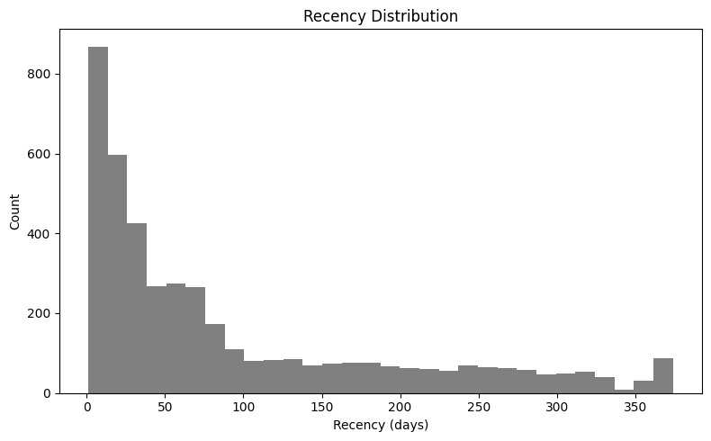
Figure 1.2: Recency shows a right-skewed distribution. Most customers made purchases within the last 50 days, while a smaller portion has not purchased for a long period (>200 days). This can serve as an important indicator of customer activity levels in the subsequent clustering analysis.
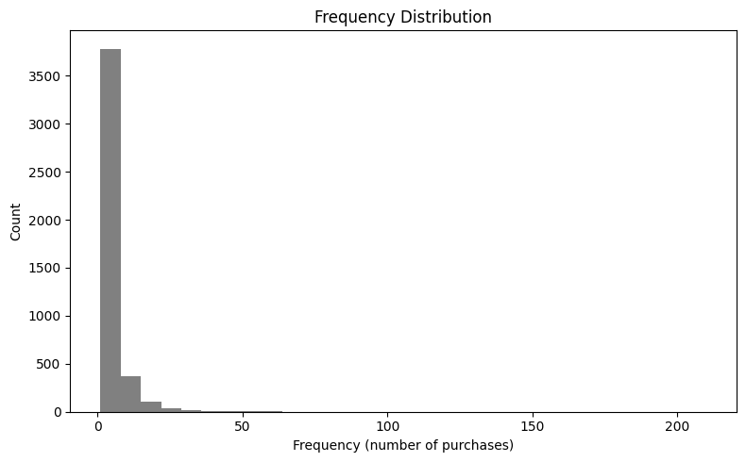
Figure 1.3: Frequency exhibits an extremely right-skewed distribution. Most customers made 1–3 purchases, with a median of 2, while the maximum reaches 210, indicating that loyal customers create a significant skew.
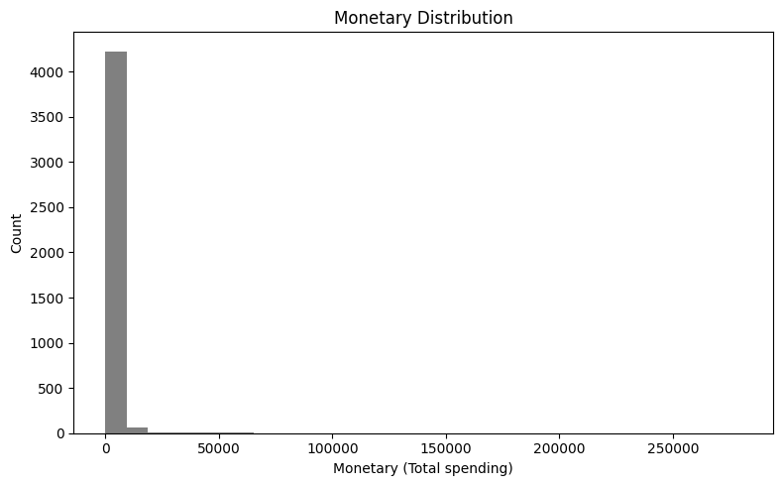
Figure 1.4: Monetary is extremely right-skewed, with a maximum value reaching 280,206 while the median is only 674. The mean value is severely inflated by enterprise clients (or corporate customers).

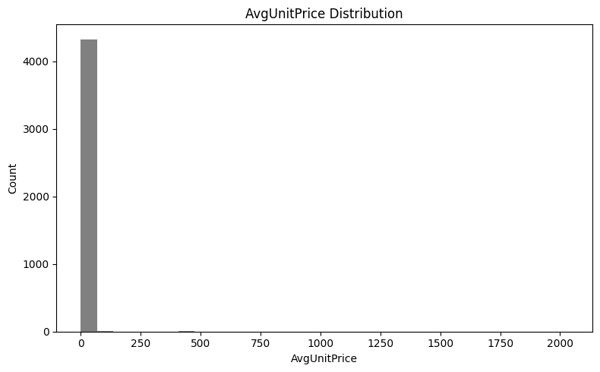
Figure 1.5: AvgUnitPrice exhibits a right-skewed distribution. The average unit price for most customers is clustered around £3, but the presence of a few high-priced items (with a maximum value of £2,033) stretches the tail of the distribution.
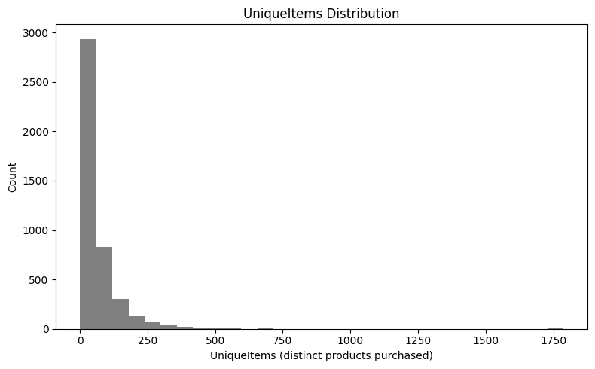
Figure 1.6: UniqueItems exhibits a long-tailed, right-skewed distribution. This suggests that most customers purchase only a small variety of items, while a minority of B2B or retailer clients purchase a large volume of different products, with the maximum reaching 1,787 types.
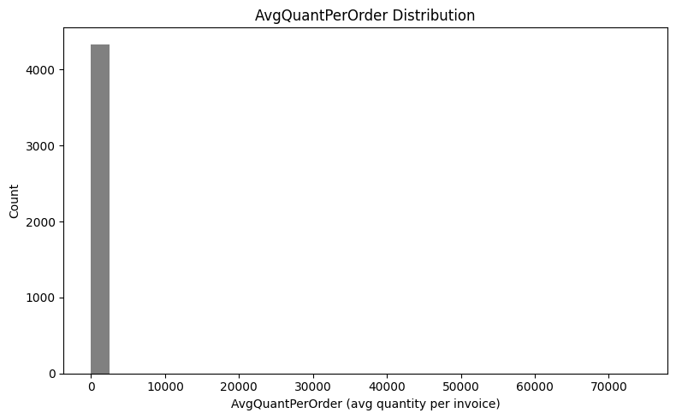
Figure 1.7: AvgQuantPerOrder is extremely right-skewed, with a maximum value of 74,215, which is significantly higher than the median of 10. This indicates that a small number of enterprise clients are making bulk purchases in a single order, thereby significantly influencing the feature distribution.
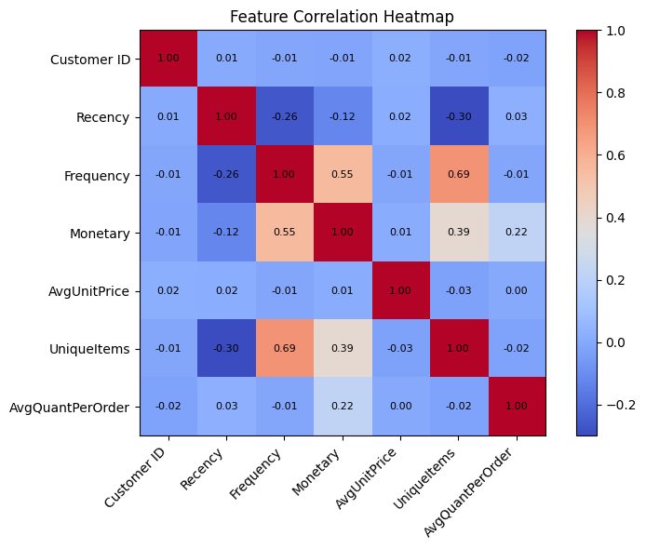
Figure 1.8: Feature correlation heatmap
- Summary
We completed data cleaning, feature aggregation, and exploratory data analysis. All features exhibit right-skewed distributions, and understanding how to handle outliers and differences in feature scales will form the foundation for subsequent dimensionality reduction and clustering.

